INTERACTIVE PHOTO GALLERY USING JAVA SCRIPT

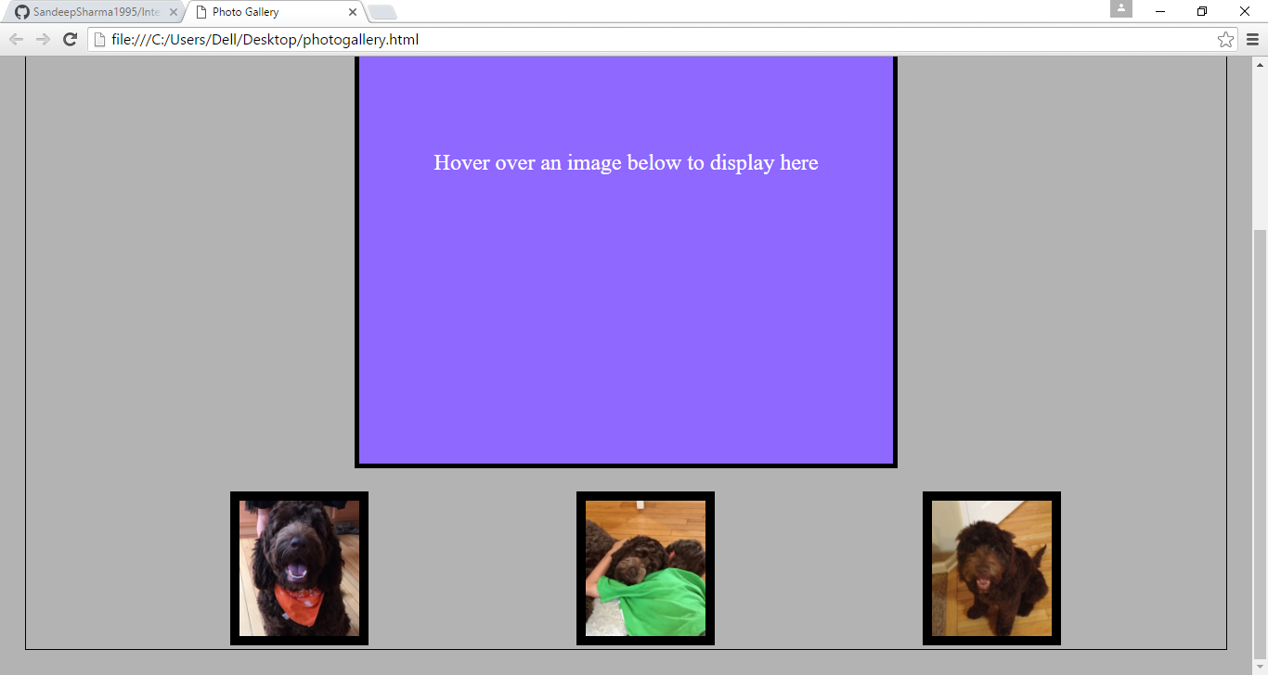

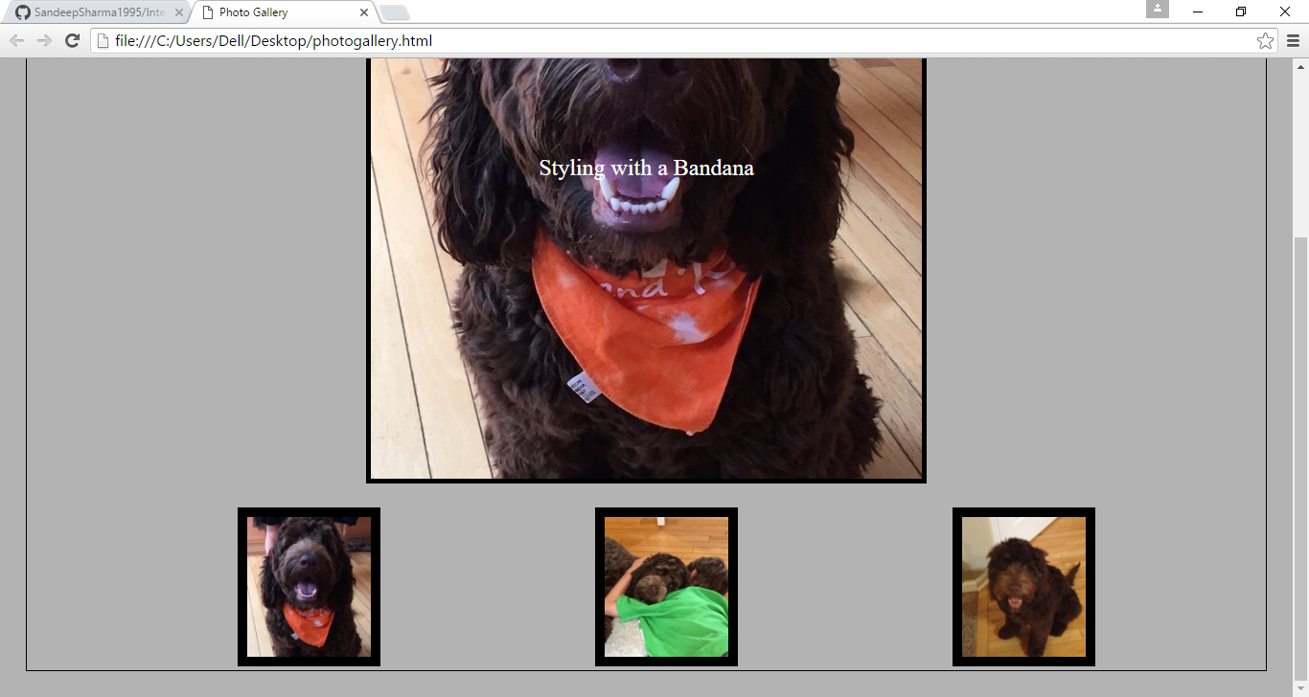

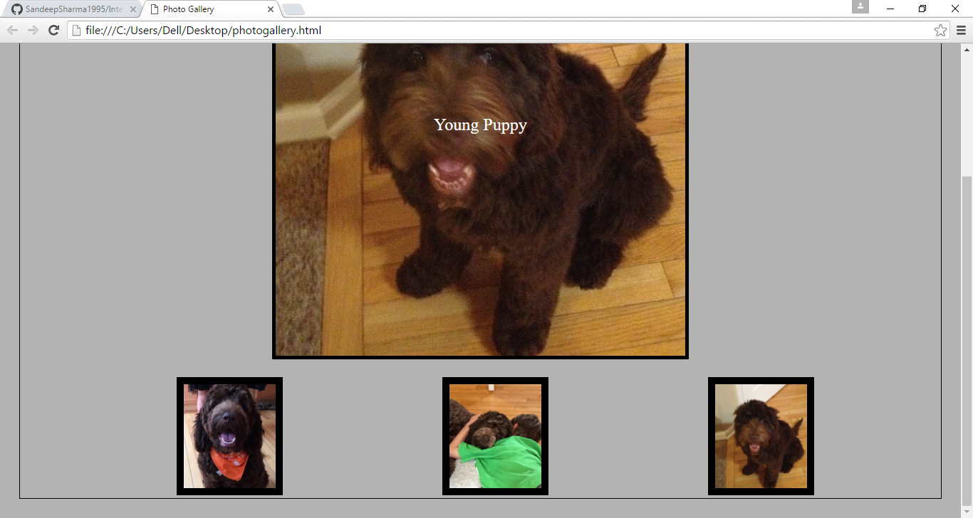

DESCRIPTION

this is an example of interactive photo gallery using javaScript.

Hover over an Image- It will show it in the div along with its alt, it uses two javaScript functions to make the changes on user's interaction.

this basic code allows one to provide interactive functionality to ones page.